Submitting your 4CCS1PPA coursework

A brief guide to the Nexus submission system

As part of your participation in 4CCS1PPA, you will be asked to complete a number of programming coursework. Many of these you will be working on during your lab sessions, some of them will be more extensive and require you to collaborate as a team over a longer period of time.

To submit your solutions to these coursework and to help us manage and mark your submissions, you will be using a new on-line system called Nexus. This document briefly outlines the steps you need to take to do so.

# Logging onto Nexus

The first time you make a submission to Nexus, you will need to log into the system and give Nexus access to your information. This requires a few additional steps, which you will only need to take once. These steps are outlined below.

To submit a solution to a piece of coursework, simply click on the appropriate link on the 4CCS1PPA KEATS page:



This will take you to the main Nexus logon page

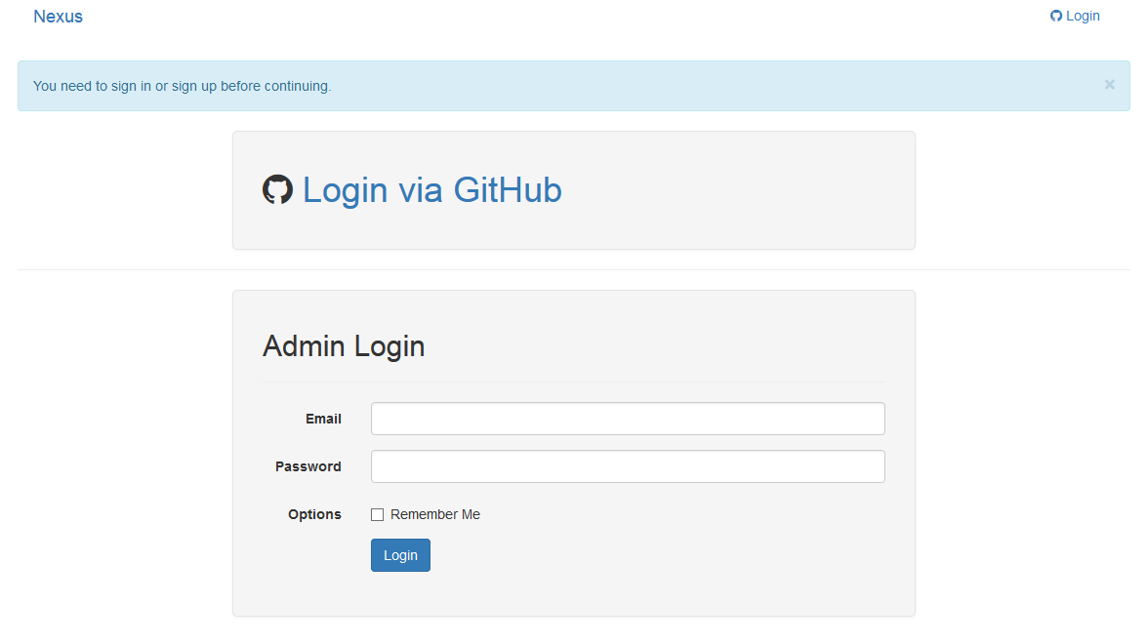

You do not have an admin login, so please choose the option to “Login via GitHub”, which will take you to a GitHub Enterprise login screen:

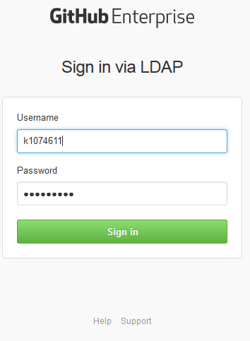

Enter your normal King’s login here and click on “Sign in”. In the next step, GitHub Enterprise will ask you to authorise Nexus to access some of your information:

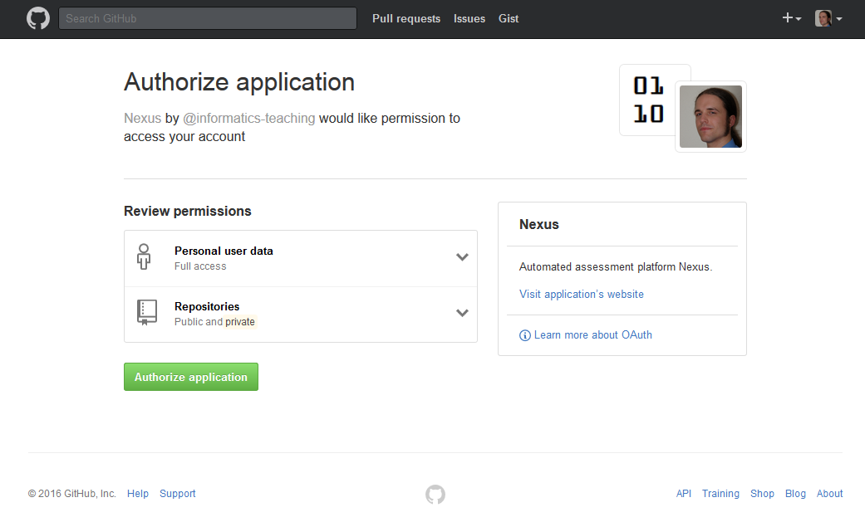

Click on “Authorize application”. Initially, Nexus will only access your personal information so that we will be able to associate a submission with you. Later during the year, we may also need to access some of your Git repositories on the King’s GitHub Enterprise server. Note Nexus will never do so without explicitly asking you for access to a specific repository. If you do not know what a Git repository is, don’t worry: we will discuss them in much more detail later in 4CCS1PPA.

For now, you will need to provide this authorisation or Nexus will not be able to accept your coursework submissions.

Once you have authorized Nexus, you will be forwarded to the page for the assignment to which you are trying to make a submission.

# Making a submission

Below is the assignment page, which you will use to make submissions.

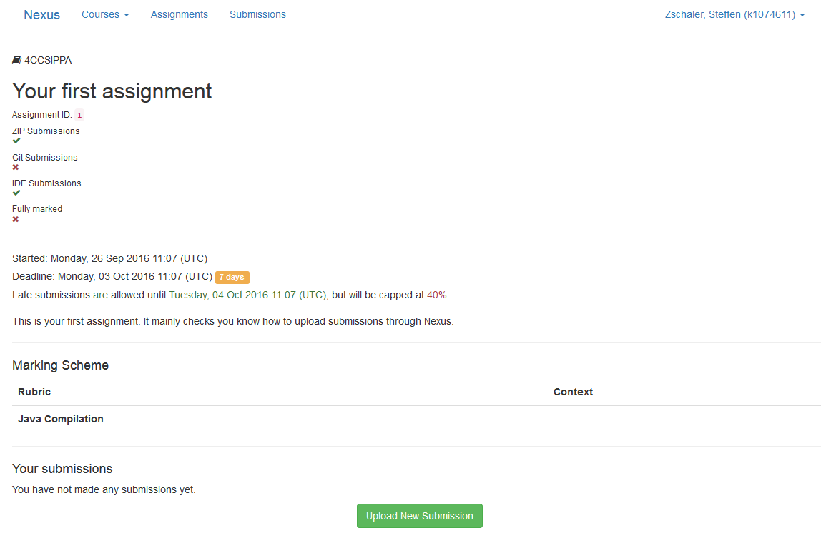

To begin with, Nexus will not actually do any of the marking.[1] However, it will already attempt to provide you with feedback to your code. You can see in the table labelled “Marking Scheme” that Nexus will attempt to compile your code and provide feedback to you about the results of that compilation as well as giving you some additional guidance about the style in which you have written your code. This way, you can check whether your code will compile when we come to marking it.

Above that table, you can find information about the deadline for submitting your work as well as about how late submissions will be handled. There may also be some more detail about the assignment here.

Click on “Upload New Submission” to make a submission. This will move you onto the submission page:

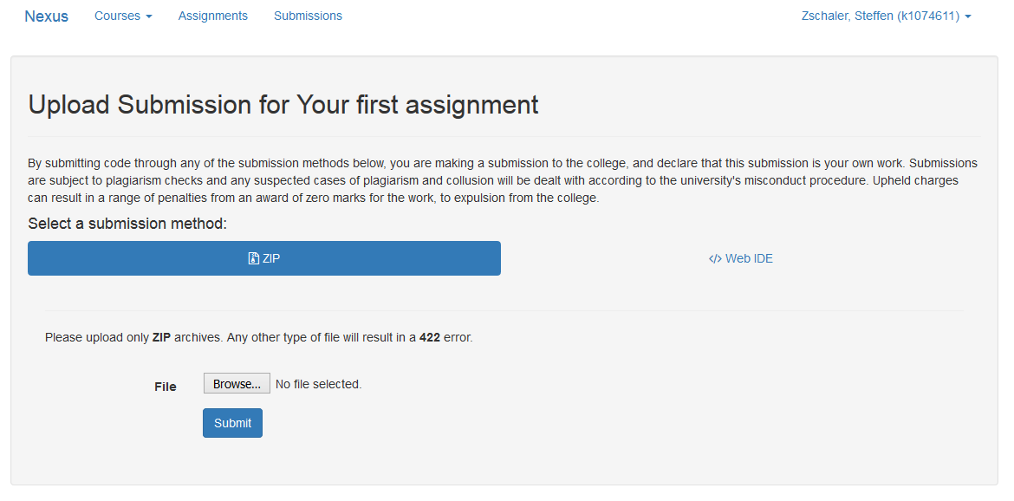

Carefully read the guidance notes before making a submission.

By default, you will be able to upload a ZIP file containing all the source files of your submission. You may also be able to use the “Web IDE”, which allows you to enter your solution directly into the web browser:

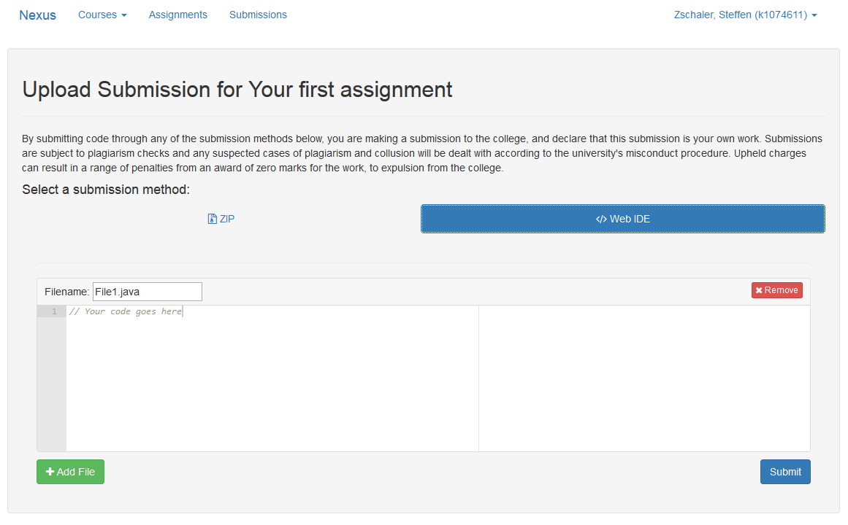

Let’s do this now. We enter some source code (changing the file name as required) and then click on “Submit”:

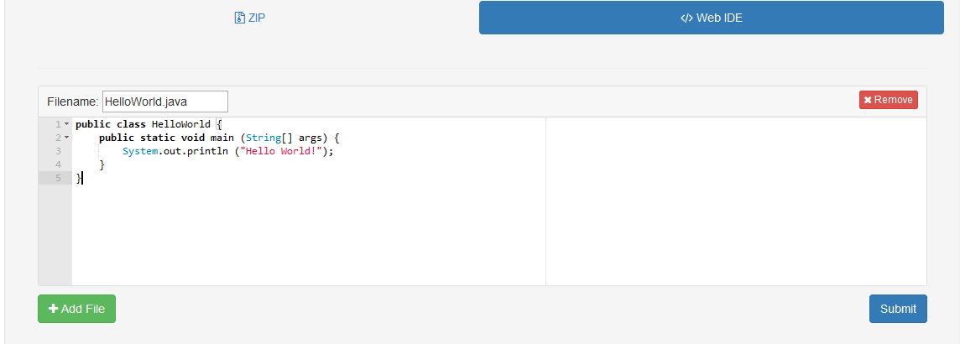

After a little while, Nexus will show a page summarising your submission attempt. If this shows any messages about problems with your submission being processed, please contact us as soon as possible so that we can check if there are any problems in Nexus. Most of the time, we should be able to rescue your submitted files so that there will be no negative consequences for your ability to submit.

Normally, however, you should simply see a page summarising your submission as below:

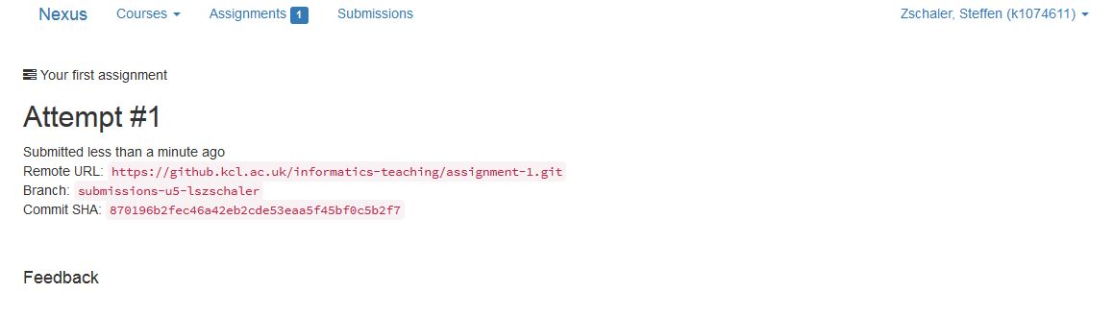

You can see that this is your first attempt at this assignment. This page is proof that Nexus has successfully received your submission and is now checking it. Initially, no text is shown below the Feedback heading. This is because Nexus doesn’t immediately complete the feedback for every submission. Instead, this may take a few minutes to complete. If you reload the page, you should be able to see your feedback:

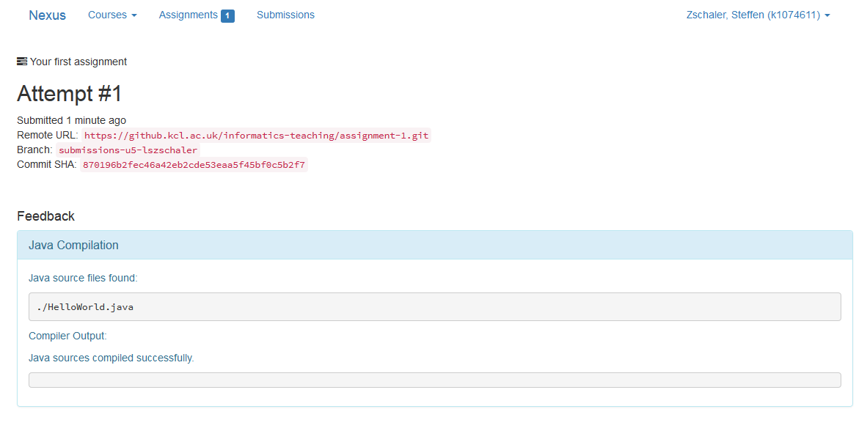

Carefully study the feedback given and, where necessary, amend your submission and resubmit. In this case, all has worked well and our code has compiled without problems.

# General points

Nexus keeps track of all of your submissions for a given assignment. If you want to check the feedback on any submission at any time, simply return to the assignment page and click on the link for the appropriate submission.

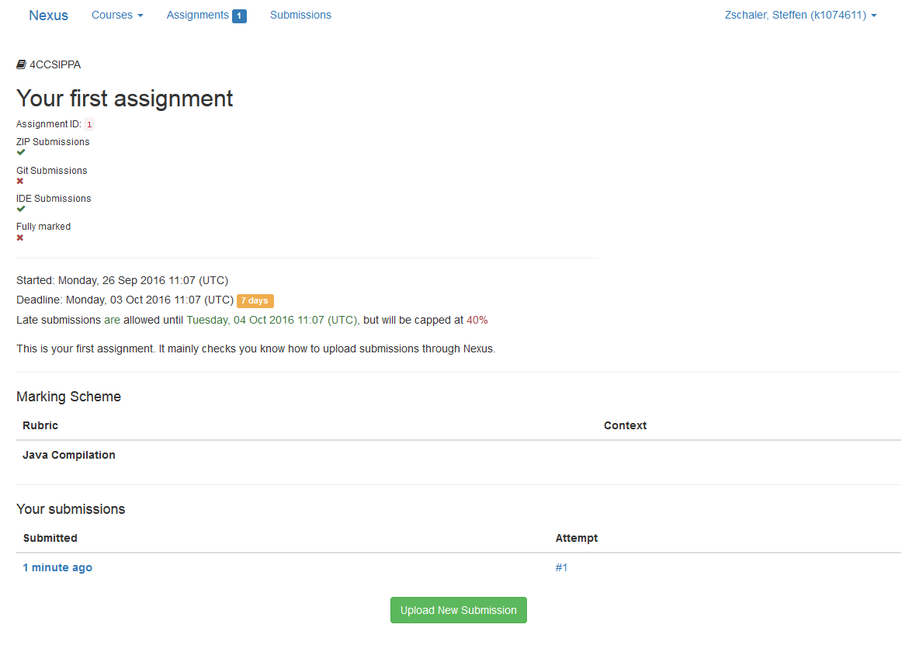

You can also use the links on the top of the page to view all of your submissions to all assignments or view all the assignments available to you for submission.

If you click on your name, a small menu pops out, allowing you to log out of Nexus:

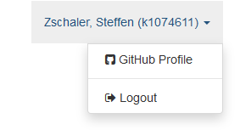

1. Because we are rolling it out slowly